Governments, Gatekeepers, and Journalists
A Briefing Paper on Internet Governance for the Center for International Media Assistance
April 24, 2013
An Overview of Internet Governance
No single entity governs the Internet. Instead, a loose network of organizations and companies makes decisions about how to develop and maintain the technical architecture of the Internet to ensure its adaptability and efficiency: so-called “multi-stakeholder” governance. Additionally, individual countries make policy decisions, which may affect Internet regulation and to varying degrees influence organizations operating within their jurisdictions. Some of the most influential organizations are:
The Internet Corporation of Assigned Names and Numbers (ICANN) distributes Internet protocol (IP) addresses and coordinates the Internet Domain Name System (DNS).
The World Wide Web Consortium (W3C) is the Internet’s main standards organization. Comprising 351 member organizations, W3C strives for consensus among industry members in adopting new technical standards.
The Internet Society (ISOC) is a leader on Internet related standards, education, and policy. ISOC promotes open Internet standards among governments to help ensure the free flow of information online.
The Internet Engineering Task Force (IETF) comprises an open community of working groups focusing on various topics vital to the development of the Internet’s core architecture and operations. Network architects, operators, researchers, and anyone interested in the working group topics can take part in the IETF’s discussions.
WCIT 2012: A Landmark in the Internet Governance Debate
In 2012 the Internet governance debate focused on the International Telecommunication Union (ITU), a UN agency. Since its founding in 1865, the ITU has grown into the UN agency responsible for allocating global radio spectrum, coordinating the assignment of satellite orbits, promoting standards related to the global telecommunications, and providing global telecommunication infrastructure development aid. The ITU comprises 193 member states and 700 sector members–NGOs, companies, and academic institutions–which cannot vote.
To the concern of civil society and digital activists, the ITU announced that its International Telecommunication Regulations (ITRs), a binding global treaty governing international telecommunication, would be revised at its global December 2012 World Conference on International Telecommunications (WCIT-12) for the first time since 1988. Throughout 2012, member states submitted proposals to update the existing ITRs, which predated the commercial Internet. Many proposals included Internet related topics, such as cyber security, deep packet inspection, traffic routing, and Internet address allocation. Groups called for transparency and the adoption of a multi-stakeholder model, rather than the traditional one country, one vote system.
The treaty, signed by 89 of the 144 eligible member states, did not grant the ITU a mandate on Internet regulation. However, the final text, which the United States, India, Japan, and most European countries refused to sign, included language that many countries felt would lead the ITU toward a greater role in future Internet governance. These included elements, such as granting “the right of access of Member States to international telecommunication services;” referring to network security and spam; and a nonbinding resolution “to foster an enabling environment for the greater growth of the Internet.”
The map below depicts the split among countries that signed the ITRs (shaded in black) and those that did not (red). Unshaded countries did not vote or did not send representatives to the WCIT-12.
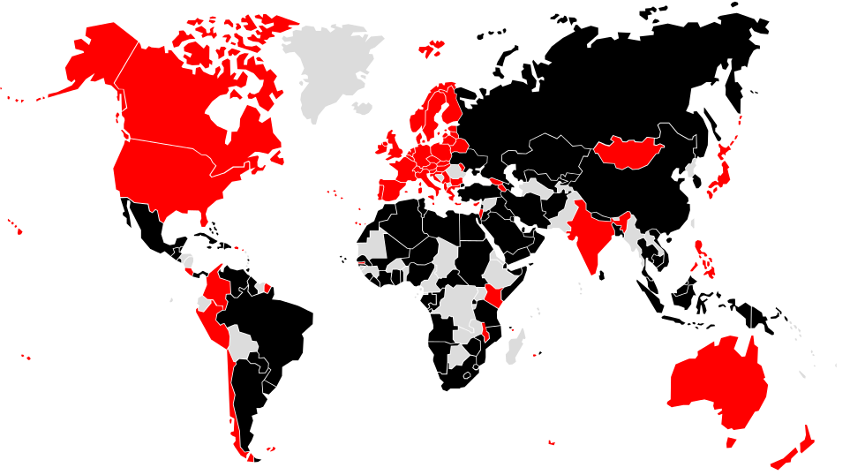
This map is updated with changes here. A full list of the 89 signatory countries is available here.
Although civil society groups and member states succeeded at the WCIT in excluding Internet governance from the ITRs, they were unsuccessful in having the issue closed permanently. Internet governance will be included in future global telecommunication discussions, and the WCIT will certainly be remembered as the watershed event that brought the topic to the world’s attention.

Discussions About Internet Governance
World Summit on the Information Society
The World Summit on the Information Society (WSIS) was a two-part United Nations event conceived to create a multi-stakeholder platform to address the development of information communication technologies (ICTs). The 2003 Geneva summit resulted in a plan of action that called for ensuring that 50 percent of the world’s population has access to ICTs by 2015. The second meeting occurred in Tunis in 2005 and resulted in the Internet Governance Forum (IGF), a multi-stakeholder group that meets annually to discuss Internet governance policy.
The first large conference in the multi-year WSIS+10 review process occurred in February 2013 at UNESCO in Paris. The event examined progress made since 2003. The discussion will continue next month in Geneva at the annual WSIS Forum. The draft agenda for the event is available here.
World Telecommunication/ICT Policy Forum
The Fifth World Telecommunication/ICT Policy Forum (WTPF) will occur at the same time as the WSIS Forum in Geneva. There ITU member states will continue the discussion from the WCIT. Civil society will have limited opportunities to participate. While no treaty will result, it will serve as an important agenda-setting conference for future ITU meetings.
ITU Plenipotentiary Conference
The ITU’s constitution will be revised at its Plenipotentiary Conference in South Korea in 2014. The governments pushing for Internet governance are likely to attempt writing the Internet into the core ITU governance document.
Key Civil Society Organizations
A number of civil society organizations work actively to take part in international Internet governance discussions.
Access Now defends the digital rights of users at risk around the world. Access helps to build technical capacities of digital activists and civil society groups and advocates for their digital rights.
The Electronic Frontier Foundation (EFF) files and defends lawsuits to protect the public’s digital rights, taking on cases that set important precedents for the treatment of rights in cyberspace.
The Center for Democracy and Technology (CDT) seeks solutions to the policy challenges facing the rapidly evolving Internet environment by advocating to both government and private industry.
Internet Governance Moving Forward
Internet governance undoubtedly will remain at the forefront of the international telecommunication policymaking process. With the debate blurred by a plethora of arcane technical considerations, the outcome remains uncertain. However, it is imperative that governments and civil society groups support the free and open Internet when developing new policy standards.
Endnotes

“Conference Concludes in Dubai With 89 Countries Having Signed the Updated International Telecommunication Regulations,” International Telecommunication Union, December 13-14, 2012, http://www.itu.int/osg/wcit-12/highlights/dec13-14.html#.UW2SPeSHeDc.
Deborah Brown, “Brief on Outcome of the World Conference on International Telecommunications,” Access Now, February 4, 2013, https://s3.amazonaws.com/access.3cdn.net/7bf90377bf58715c0a_j8m6iv2rt.pdf.
Richard Barnes, “Country Positions on ITR Proposed at WCIT 2012,” http://www.ipv.sx/wcit/.
“Signatories of the Final Acts: 89,” International Telecommunication Union, http://www.itu.int/osg/wcit-12/highlights/signatories.html.
“WSIS Forum 2013 Agenda,” World Summit on the Information Society, https://www.itu.int/wsis/implementation/2013/forum/agenda.html.
“World Telecommunication/ICT Policy Forum (WTPF) Issues to Watch,” Center for Democracy and Technology, https://www.cdt.org/files/file/analysisofWTPFreport.pdf.
Information about the civil society organizations was pulled from their websites. Follow CIMA! Follow CIMA on Twitter at @CIMA_Media for regular updates about Internet governance and media development.

